SECURE LOGIN SYSTEM

Submitted By
Name: KANIYAMUTHU B
Department: Information Technology

Abstract
The Secure Login System is a Python-based application developed to provide secure authentication for users. The system allows users to register and log in using encrypted passwords stored in a SQLite database. Passwords are protected using the bcrypt hashing algorithm, ensuring that sensitive information is never stored in plain text. The project also includes input validation, secure database queries to prevent SQL injection, and session management to enhance application security.

Introduction
Authentication is an essential component of every web application. Many cyberattacks target login systems through weak passwords and SQL injection attacks. This project demonstrates how a secure login system can be built using Python while following modern security practices such as password hashing and secure database operations.

Objectives
- Develop a secure user authentication system.
- Store passwords using bcrypt hashing.
- Prevent SQL Injection attacks.
- Validate user inputs.
- Implement secure login and logout functionality.
- Store user details using SQLite database.

Software Requirements
- Python 3.x
- Google Colab or Visual Studio Code
- SQLite Database
- bcrypt Library

Hardware Requirements
- Intel Core i3 Processor or above
- 4 GB RAM or higher
- 200 MB Free Disk Space

Technologies Used
- Python
- SQLite
- bcrypt
- Google Colab
- SQL Queries

Modules

Module 1: User Registration
- Register new users.
- Check for duplicate usernames.
- Encrypt passwords before storing.

Module 2: User Login
- Authenticate users using stored credentials.
- Verify hashed passwords using bcrypt.

Module 3: Password Security
- Passwords are hashed using bcrypt.
- Plain-text passwords are never stored.

Module 4: Database Management
- Store user details securely in SQLite.
- Retrieve user information using parameterized queries.

Algorithm
- Start the program.
- Display the main menu.
- If the user selects Register:
  - Enter username.
  - Enter password.
  - Hash the password.
  - Store data in SQLite database.
- If the user selects Login:
  - Enter username.
  - Enter password.
  - Verify the password using bcrypt.
  - If valid, display "Login Successful".
  - Otherwise, display "Invalid Username or Password".
- Exit the application.
Screenshots

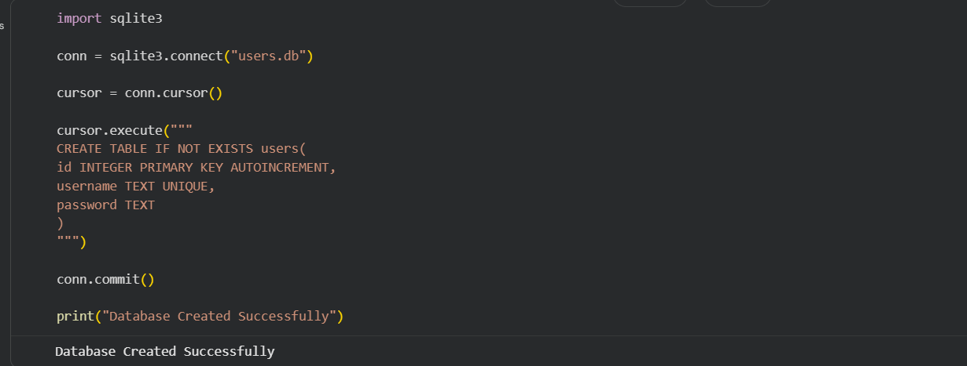

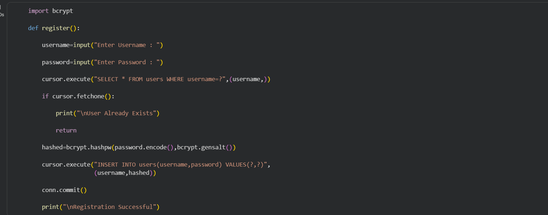

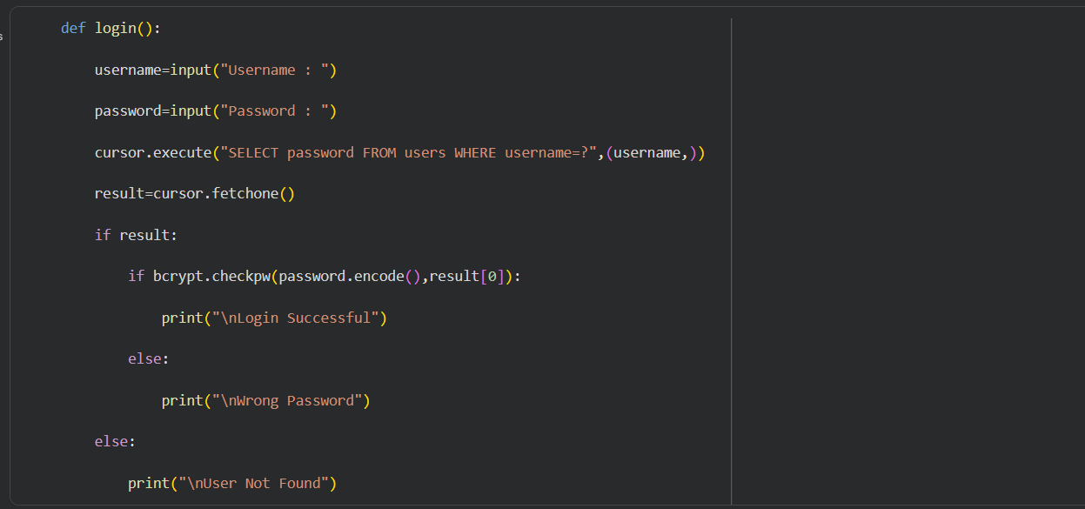

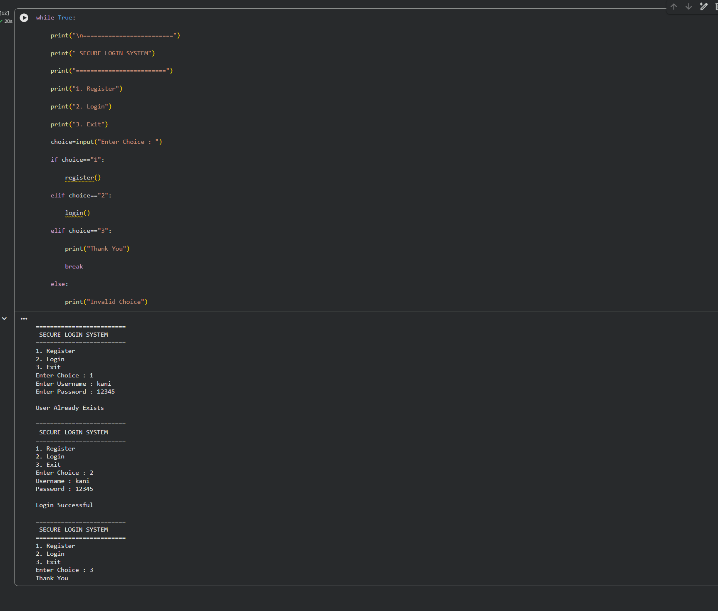

Security Features
- Password Hashing using bcrypt.
- SQL Injection Protection through parameterized queries.
- Input Validation.
- Secure SQLite Database.
- User Authentication.
- Login Verification.

Future Enhancements
- Email Verification
- OTP Authentication
- Password Reset Feature
- Biometric Authentication
- Multi-Factor Authentication
- Cloud Database Integration

Expected Output
The application allows users to register with a username and password, securely stores the password in encrypted form, and authenticates users during login. Unauthorized users cannot access the system, ensuring secure authentication and data protection.

Conclusion
The Secure Login System demonstrates the implementation of secure authentication using Python and SQLite. By employing bcrypt password hashing and parameterized database queries, the application protects user credentials against common security threats such as password theft and SQL injection. The project provides a strong foundation for developing secure authentication systems for modern web applications.

References
- Python Official Documentation
- SQLite Documentation
- bcrypt Documentation
- Google Colab Documentation

